**LABCYCLE :1**

**EXPERIMENT: 2**

**AIM** :To Install Ubuntu on Windows 10 With VirtualBox..

To install Ubuntu as a virtual machine on Windows 10:

1. [Download VirtualBox](https://www.virtualbox.org/wiki/Downloads) for Windows and install it on your computer.

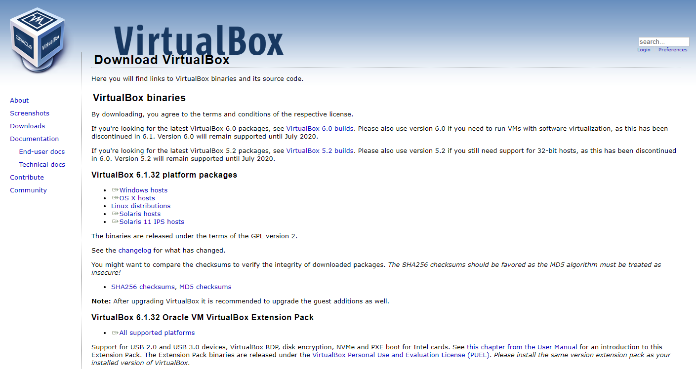

1. Download the Ubuntu [ISO file](https://www.lifewire.com/iso-file-2625923) you want to install from the [Ubuntu download page](https://ubuntu.com/download/desktop).

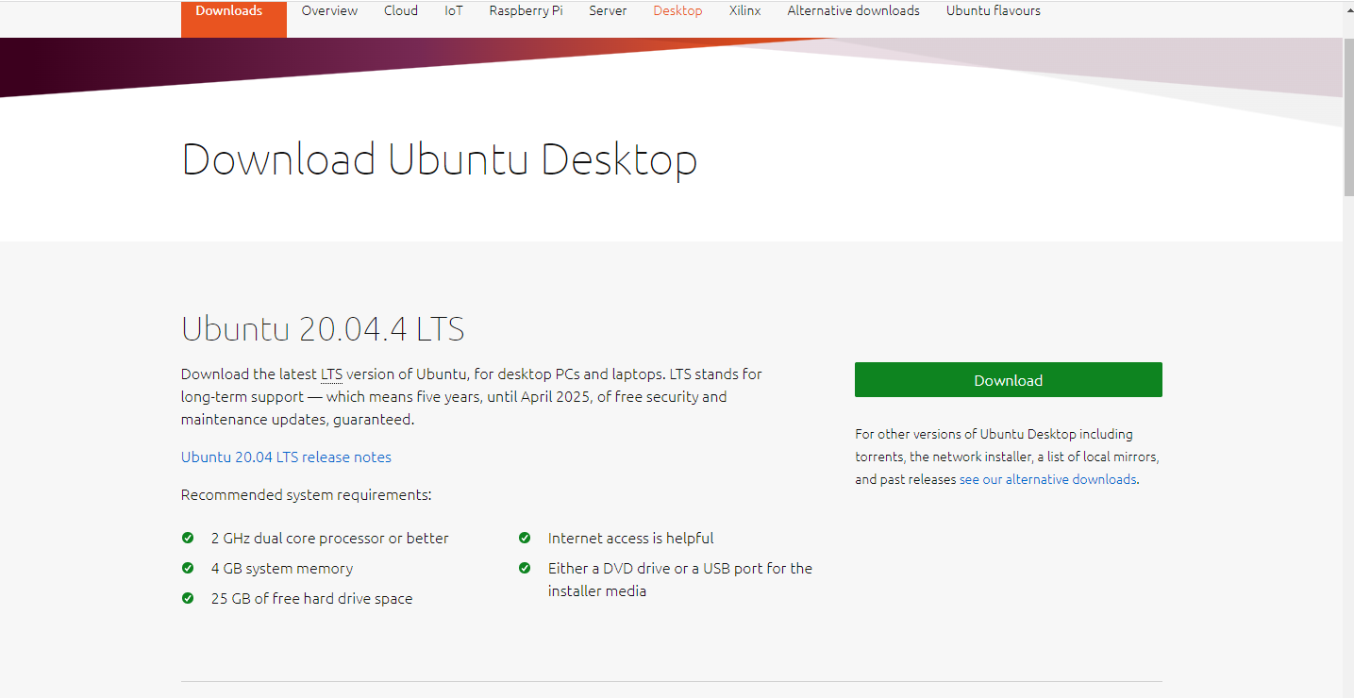

The current version of Ubuntu only works on [64-bit](https://www.lifewire.com/32-bit-64-bit-2624554) machines. Check the [Windows Control Panel](https://www.lifewire.com/how-to-open-control-panel-2625782) to [tell if you're running a 32-bit or 64-bit system](https://www.lifewire.com/am-i-running-a-32-bit-or-64-bit-version-of-windows-2624475).

1. Open VirtualBox and select **New** in the top taskbar.

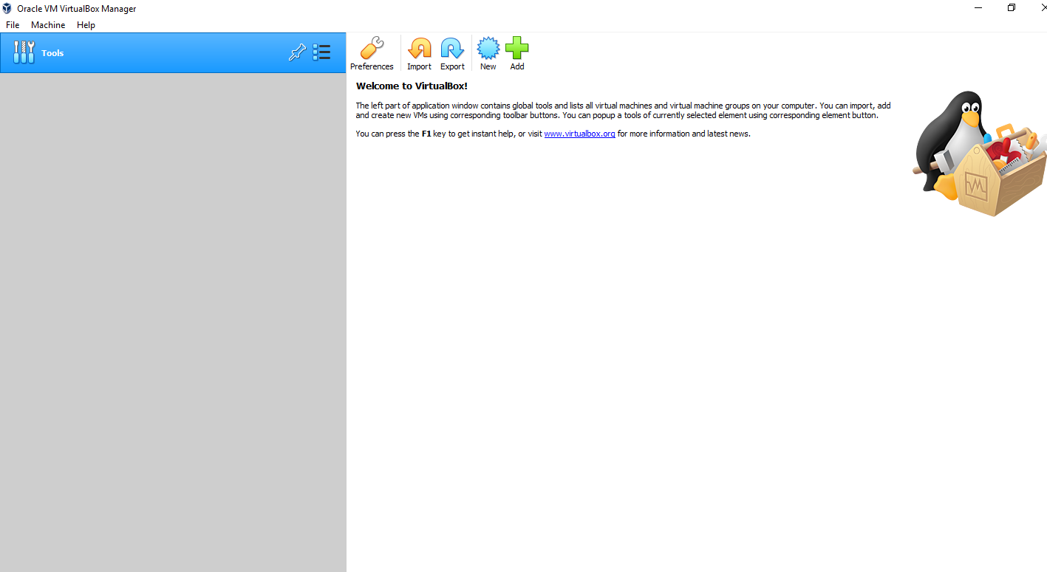

1. Give your VM a name, choose **Linux** as the **Type**, then choose **Ubuntu** as the **Version**and select **Next**.

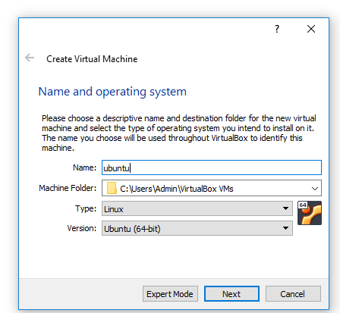

If you're using a 32-bit version of Windows, you can install an older 32-bit version of Ubuntu instead.

1. Choose how much [RAM](https://www.lifewire.com/what-is-random-access-memory-ram-2618159) you want to assign to the virtual machine and select **Next**. The recommended minimum is 1024 [MB](https://www.lifewire.com/what-is-a-megabit-2483412).

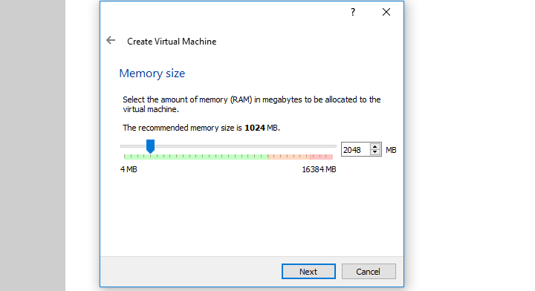

The amount of memory you set aside is only used while the virtual machine is running.

1. Choose **Create a virtual hard disk now** and select **Create**.

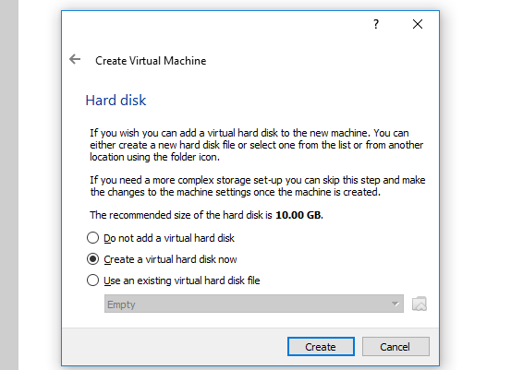

If you just want to run Ubuntu as a live image, choose **Do not add a virtual hard disk**. You must create a virtual hard drive to save the changes you make in Ubuntu.

1. Choose **VDI**(VirtualBox Disk Image) and select **Next**.

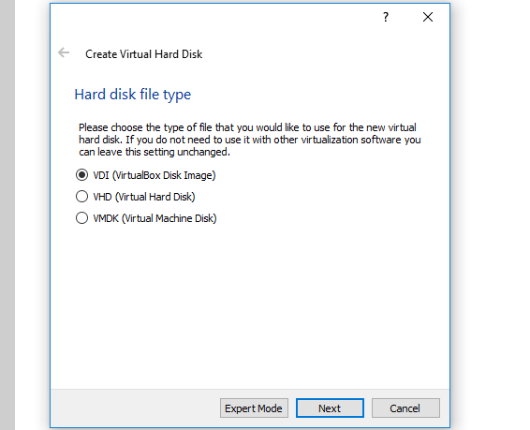

1. Choose **Dynamically allocated** or **Fixed size** for the storage type and select **Next**.

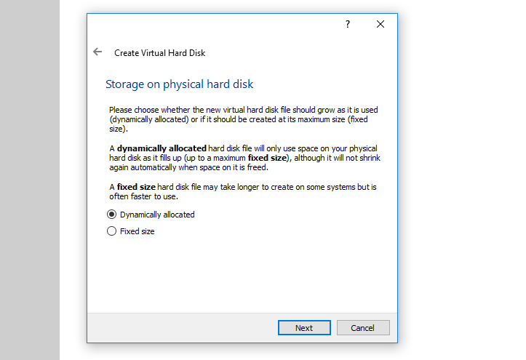

A fixed size disk performs better because the virtual machine doesn't have to increase the file size as you [install software](https://www.lifewire.com/how-to-safely-download-install-software-2625183).

1. Choose how much space you wish to set aside for Ubuntu and select **Create**.

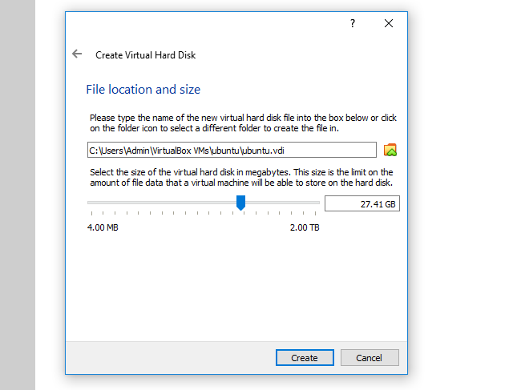

The amount of space you allocate for your virtual machine determines how much room you have to install applications, so set aside an ample amount.

1. The name of your virtual machine will now appear on the left side of the VirtualBox manager. Select **Start** in the toolbar to launch your VM.

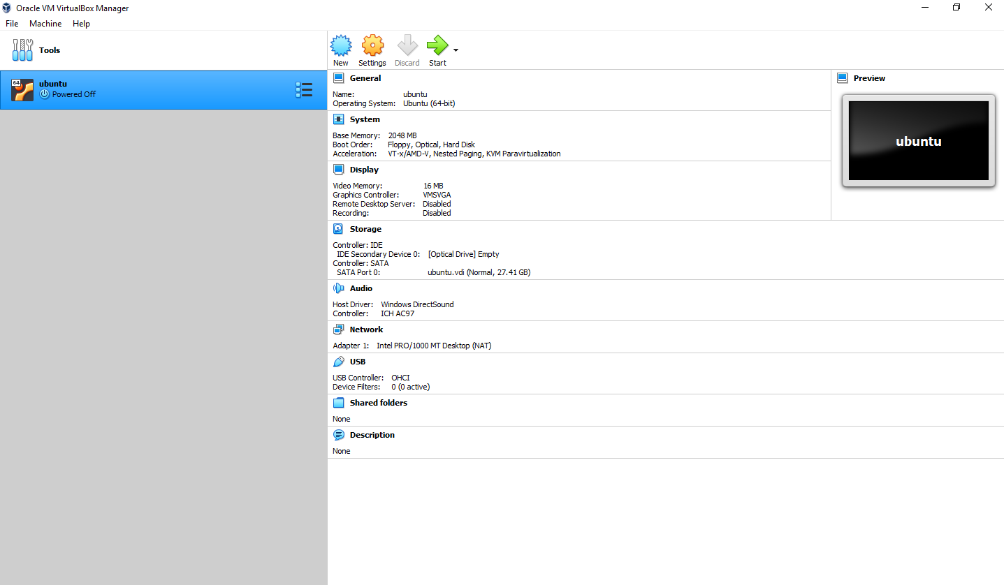

1. This is the point where you need to choose the Ubuntu ISO file you downloaded earlier. If the VM doesn't automatically detect it, select the **folder** next to the **Empty** field.

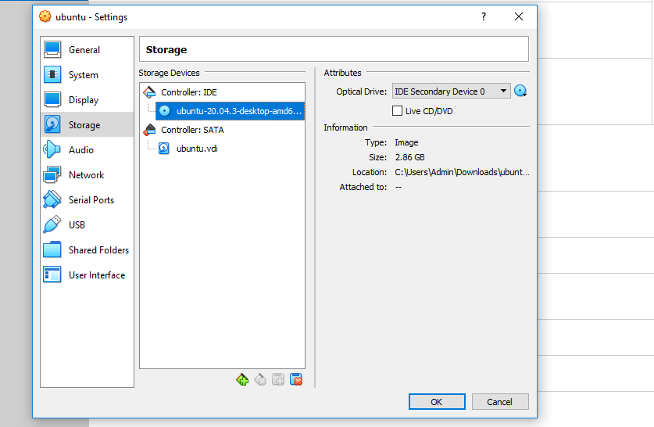

1. Choose your Ubuntu disk image and select **Open.**

Select START.

1. Your VM will now boot into a live version of Ubuntu. Choose your language and select **Install Ubuntu**.

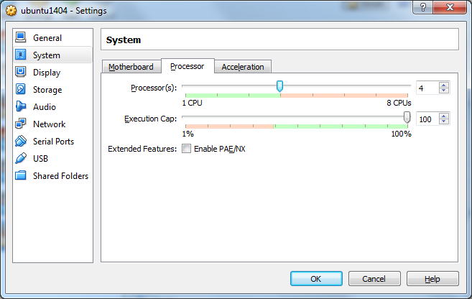

If you select **Try Ubuntu**, you can run the installer later by double-clicking **Install Ubuntu** on the desktop.

1. Choose your keyboard layout and select **Continue**.

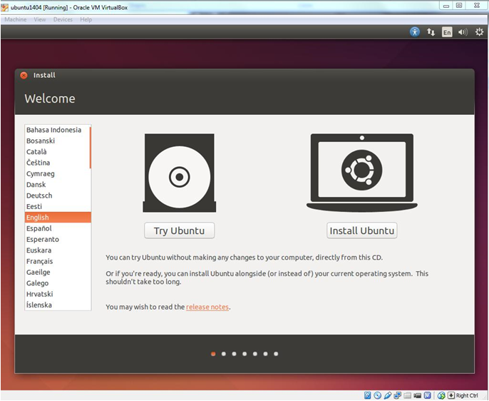

1. Choose **Normal installation** or **Minimal installation**, then select **Continue**.

Check the boxes under **Other Options**to download updates and [install third party software for Ubuntu](https://www.ubuntu4u.com/tips-and-tricks/install-third-party-software-during-the-ubuntu-set-up).

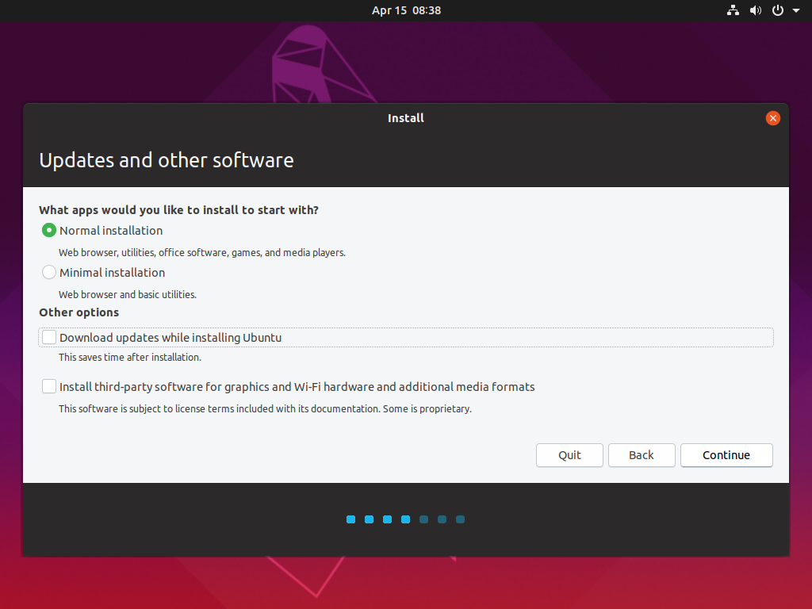

1. Choose **Erase disk and install Ubuntu** and select **Install Now**, then select **Continue** to ignore the warning.

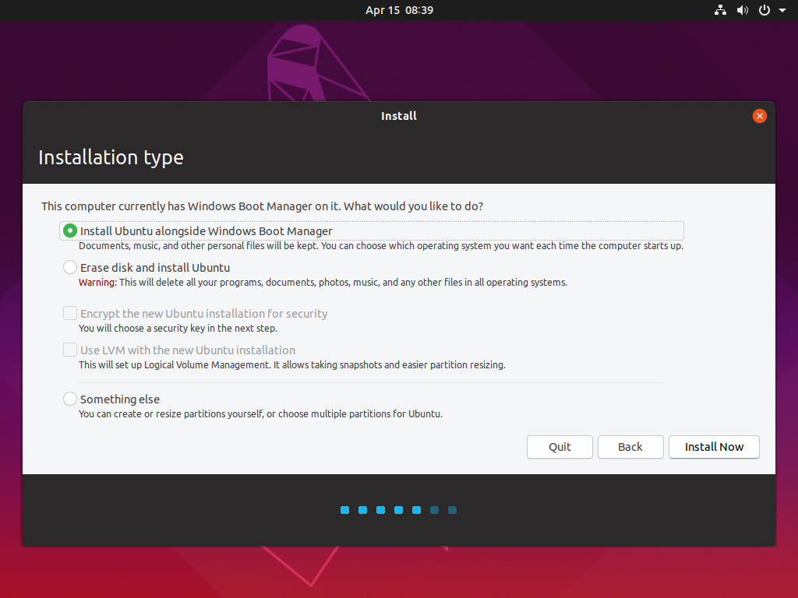

This step will not erase your computer's physical hard drive; it only applies to the

virtual machine.

1. Choose your time zone on the map, then select **Continue**.

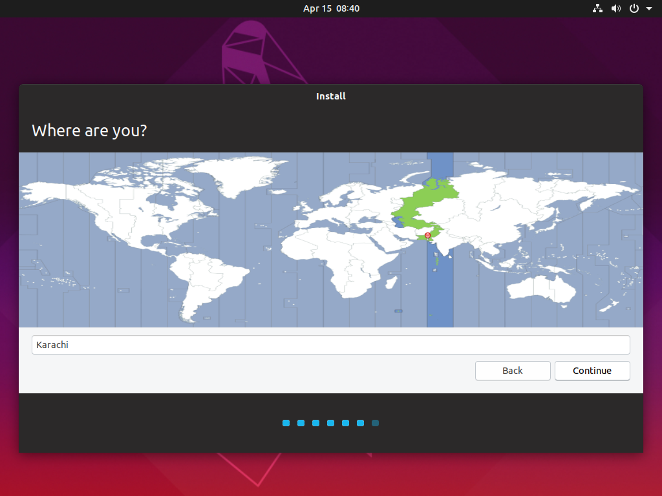

1. Set up your user account and select **Continue**.

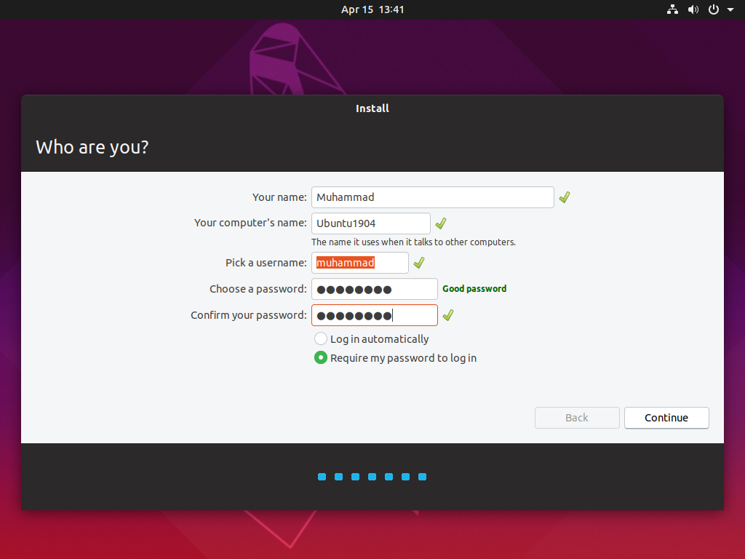

1. You are almost done. It may take 10-15 minutes to complete the installation.

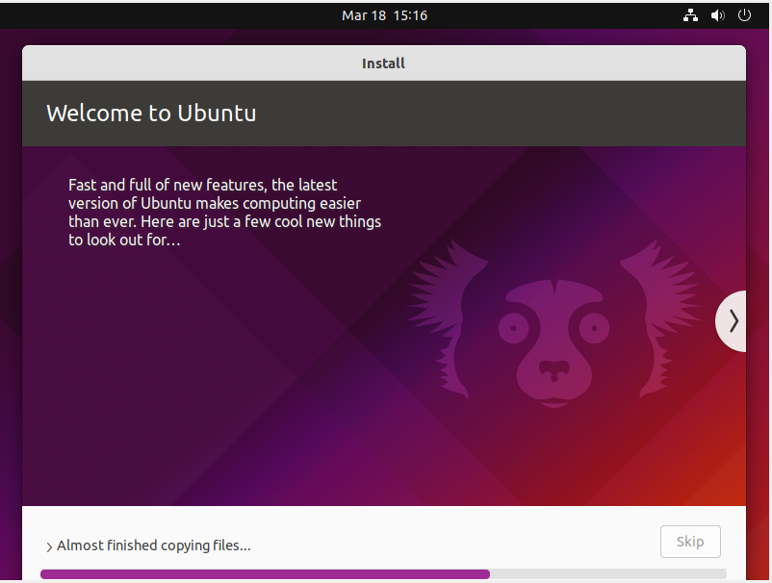

1. Once the installation finishes, restart the virtual system.

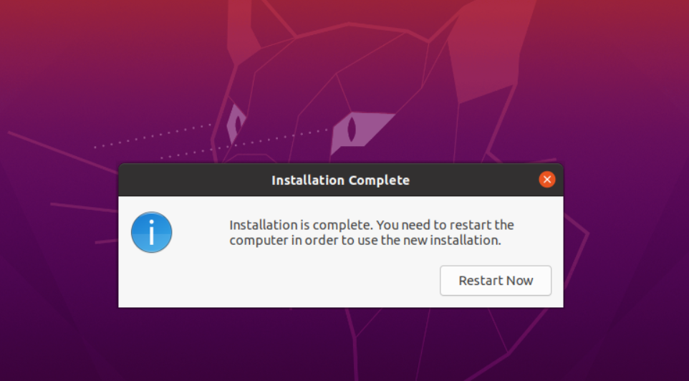

21. From now on, just click on the installed Linux virtual machine. You’ll be able to use it directly.

